LABORATORIO ARTIGIANO RETI
di ARCHETTI CARLO
Reti da Pesca – Sport – Caccia
Recinzione Impianti Sportivi
Antinfortunistica – Acquacoltura
25058 SULZANO (BS) – Via Tassano, n. 8
Tel. e Fax 030/985290 – Tel. Ab. 030/985191
Cell. 328 0562071 c.f. RCHCRL64C01F532U – P.I. 03216410179
www.retiarchetti.it – info@retiarchetti.it
www.retiarchetti.com – info@retiarchetti.com
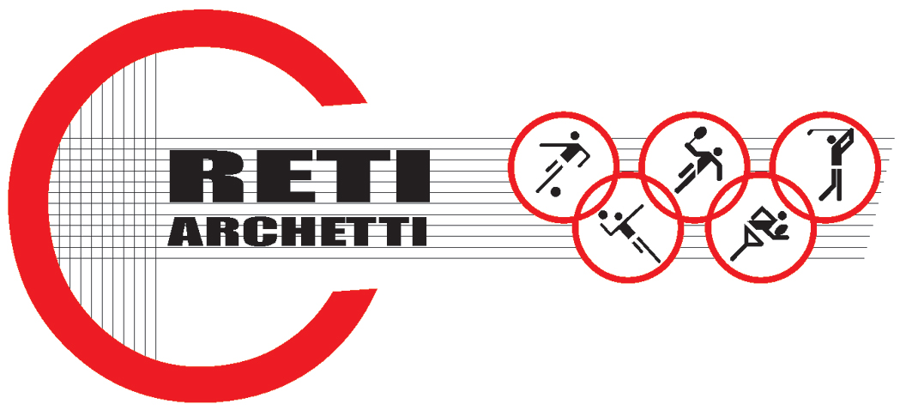

TECHNICAL DATA SHEET ART.CODE: A 18

NET MADE OF POLYETHYLENE, STABILIZED AGAINST UV RAYS, MESH mm 45 x 45, THICKNESS MM 3

STATIC TESTS: tests carried out with a polyethylene net, without knot, green colored (title 15/032, braid Ø mm 3 and mesh mm 45) according to Standard EN 1263-1.
Hereafter the results obtained with tests on samples of a brand new net, dimensions 3 x 3:

AVERAGE ULTIMATE STRENGTH: 879 daN

Technical features

- MATERIAL: High resistant Polyethylene, stabilized against UV rays, water repellent.
- AVAILABLE COLORS: green or white
- YARN THICKNESS: 3 mm.
- NET: squared mesh
- MESH: mm. 45 x 45
- WEIGHT: g. 120/sq. m
- EDGE STRIP: with a 6 mm polyethylene braid.
- FUSION TEMPERATURE: 120° C
- MIN. USE TEMPERATURE: – 40° C
- WATER ABSORPTION: 0,01% - WATER REPELLENT –
- MOTH RESISTANCE = ABSOLUTE
- MOULD RESISTANCE = ABSOLUTE
- ABRASION RESISTANCE = EXCELLENT
- MINERAL ACIDS = RESISTANT
- ORGANIC ACIDS = RESISTANT
- ALKALI = RESISTANT
- OIL = RESISTANT

Each net can be manufactured with length and width on customer request. Nets are complete with a reinforced strip along the edge with a 6 mm braid sewed to the net. A piece of rope at the angles makes the installation easier.

